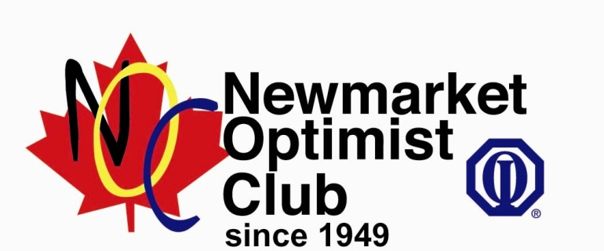
\\\\\\\\\\\\\\\\\\\\
Driver/Passenger Name: ___________________________________________

On Saturday, June 10, 2023 we will be participating in the Newmarket Optimist Club 10th Annual Poker Ride for Kid’s Cancer. All proceeds raised will be donated to the Southlake Regional Health Centre Paediatric Oncology Centre. Please check if you wish to receive a tax receipt.
I hope you can help by sponsoring me.
Name | Phone # | Mailing Address | Pledge Amount | Email address | Tax Receipt

